Mini Project Report

**On**

**Doctor’s Appointment Website**

**Submitted by**

**HIMANSHU NAGAR**

**Roll No:171500135**

**&**

**CHAUDHARY NITIN**

**Roll No:171500086**

Department of Computer Engineering & Applications

**Institute of Engineering & Technology**



**GLA University, Mathura- 281406, INDIA**

**Department of computer Engineering and Applications**

**GLA University, Mathura**

**17 km. Stone NH#2, Mathura-Delhi Road, P.O. – Chaumuha,**

**Mathura – 281406**



**Declaration**

*We hereby declare that the work which is being presented in the Mini Project Titled:* ***“Doctor’s Appointment Website”,*** *in partial fulfilment of the requirements for Mini-Project LAB, is an authentic record of our own work carried under the supervision of* ***Mr. Pankaj Kapoor, Technical Trainer, GLA University, Mathura****.*

Himanshu Nagar (171500135)

Chaudhary Nitin (171500086)

**ABSTRACT**

The main objective is to develop a website that can provide a better way of making appointment of doctors. It enables healthcare providers to improve operational effectiveness, reduce costs, reduce medical errors, reduce time consumption and enhance delivery of quality of care. This system help reduce the problems occur when using the manual system and helps patients to skip endless queues. This website will mail details of the patient and other information to the doctor. As we saw patients make queues to fix appointment to a doctor. This take too much time and the patient has to sit there for their turn, With this website the time will decrease and patient doesn’t have to wait for his turn.

Once a patient fill the “Appointment Form” the e-mail will be sent to doctor’s email.

We are working on this project as this project is helpful for both Doctors as well as Patients.As this project provides efficient facility for the Patient to view their treatment details and for the doctors to review the health of patient from initial to final stage of treatment. Therefore we came with this project.

**CERTIFICATE**

*This is to certify that the project entitled* ***“Doctor’s Appointment Website”*** *carried out in Mini Project – II Lab is a bonafide work done by* ***Himanshu Nagar(171500135), Chaudhary Nitin(171500086)*** *and is submitted in partial ulfilment of the requirements for the award of the degree Bachelor of Technology (Computer Science & Engineering).*

**Signature of Supervisor:**

**Name of Supervisor: Mr. Pankaj Kapoor**

**ACKNOWLEDGEMENT**

*It gives us a great sense of pleasure to present the report of the B. Tech Mini Project undertaken during B. Tech. Third Year. This project in itself is an acknowledgement to the inspiration, drive and technical assistance contributed to it by many individuals. This project would never have seen the light of the day without the help and guidance that we have received.*

*Our heartiest thanks to* ***Dr. (Prof). Anand Singh Jalal,*** *Head of Dept., Department of CEA for providing us with an encouraging platform to develop this project, which thus helped us in shaping our abilities towards a constructive goal.*

*We owe special debt of gratitude to* ***Mr. Pankaj Kapoor,*** *Technical Trainer, Department of CEA, for his constant support and guidance throughout the course of our work. His sincerity, thoroughness and perseverance have been a constant source of inspiration for us. He has showered us with all his extensively experienced ideas and insightful comments at virtually all stages of the project & has also taught us about the latest industry-oriented technologies.*

*We also do not like to miss the opportunity to acknowledge the contribution of all faculty members of the department for their kind guidance and cooperation during the development of our project. Last but not the least, we acknowledge our friends for their contribution in the completion of the project.*

### TABLE OF CONTENTS

|  |
| --- |
| INTRODUCTION ………………………………………………. 7 1.1 Motivation ………………………………………………………………………7  1.2 Objective ………………………………………………………………. .. . . .. ..7  1.3 Basic Terms Used ………………………………………………………………7 |
| SYSTEM REQUIREMENT & ANALYSIS ……………………9  * 1. Problem Statement in **Existing System**…………………………………………..9   2. **Proposed System to Resolve the Problem**………………………………………9   3. Software Requirement specification…………………………………………..12   4. Software Tecnologies Used……………………………………………………….19   5. Hardware Requirements ………………………………………………………..21   6. Software Designing………………………………………………………..10      1. ER diagram……………………………………………………….. 10      2. Sequence diagram………………………………………………………11 |
| Implementation and USER INTERFACE …………………… 22  * 1. User Interface …………………………………………………………………. 22   2. Implementation …………………………………………………………………26  Testing…………………………………………………………………16 |
| REFRENCES / BIBILIOGRAPGY …………………………..39 |
| FUTURE PROSPECTUS……………………….……………41 |
| 1. **CONCLUSION…………………………..………………………41** |
|  |

**CHAPTER 1**

**Introduction**

* 1. **Motivation**

 As we saw patients make queues to fix appointment to a doctor. This take too much time and the patient has to sit there for their turn, With this website the time will decrease and patient doesn’t have to wait for his turn.

We are working on this project as this project is helpful for both Doctors as well as Patients. As this project provides efficient facility for the Patient to view their treatment details and for the doctors to review the health of patient from initial to final stage of treatment. Therefore we came with this project.

**1.2 Objective**

The main objective is to develop a website that can provide a better way of making appointment of doctors. It enables healthcare providers to improve operational effectiveness, reduce costs, reduce medical errors, reduce time consumption and enhance delivery of quality of care. This system help reduce the problems occur when using the manual system and helps patients to skip endless queues. This website will mail details of the patient and other information to the doctor.

**1.3 Basic Terms Used**

**1.3.1 HTML –** Hypertext Markup Language is the standard markup language for documents designed to be displayed in a web browser. It can be assisted by technologies such as Cascading Style Sheets and scripting languages such as JavaScript.

**1.3.2 CSS –** Cascading Style Sheets is a style sheet language used for describing the presentation of a document written in a markup language like HTML. CSS is a cornerstone technology of the World Wide Web, alongside HTML and JavaScript.

**1.3.3 JavaScript –** JavaScript, often abbreviated as JS, is a high-level, interpreted scripting language that conforms to the ECMA Script specification. JavaScript has curly-bracket syntax, dynamic typing, prototype-based object-orientation, and first-class functions.

**1.3.4 Bootstrap –** Bootstrap is a free and open-source CSS framework directed at responsive, mobile-first front-end web development. It contains CSS and JavaScript-based design templates for typography, forms, buttons, navigation and other interface components.

**1.3.5 PHP** – PHP (recursive acronym for PHP: Hypertext Preprocessor) is a widely-used open source general-purpose scripting language that is especially suited for web development and can be embedded into HTML.

**CHAPTER 2**

**Software Requirement Analysis**

**Problem Statement in Existing System:**

In the existing system the patient needs to visit the doctor for booking we need to wait and the booking will be done manually so to maintain everything is always a problem. It’s a time taking process to visit the hospital and book the appointment and also the fuel and energy is wasted as the patient sometimes has to make two round trips to the hospital first for making an appointment and another for Checkup. And there is sometimes a huge crowd for making appointments which might cause inconvenience. And due to this sometimes there is a huge load on the Doctors.

**Proposed System to Resolve the Problem:**

In the proposed system the doctors patients are brought to one platform will allow patients to be more flexible they can register and search for the doctors basing on the location the list of doctors will be shown and patient can book by selecting  the time slots and the admin will confirm the booking so everything is computerized an done very fast which will save time. And the patient has not to visit the hospital for booking appointments instead they can book the appointments from a smart phone or a computer system from wherever they are and that too anytime they want to book the appointment. And this makes it convenient and there is not a crowd at the clinic due to this.

**Software Design:**

**ER Diagram:**

Makes

patient

Appointment

attends

Checks up

Doctor

**Sequence Diagram :**

Patient

Office Staff

Appointment

Doctor

Patient Check

Appointment Availability

Doctors

Available Schedules Ask for

Confirmation

Select

Mail Information

fix appointment mail

Sequence Diagram

**Software Requirements specification:**

**1 Appointment Button**

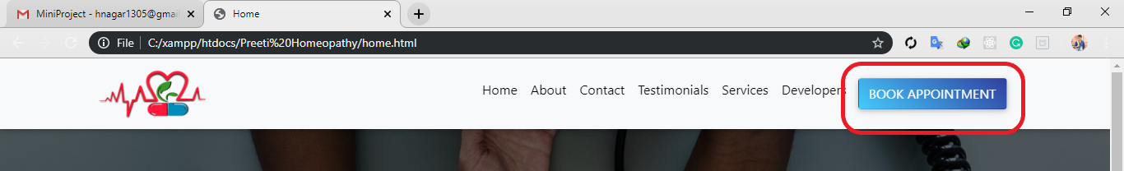

Appointment Buttonis use to make an appointment with the doctor, by clicking this button user will get an appointment form, on which user will put personal details and send it to doctor’s email to confirm his/her appointment.

**2 Appointment Form**

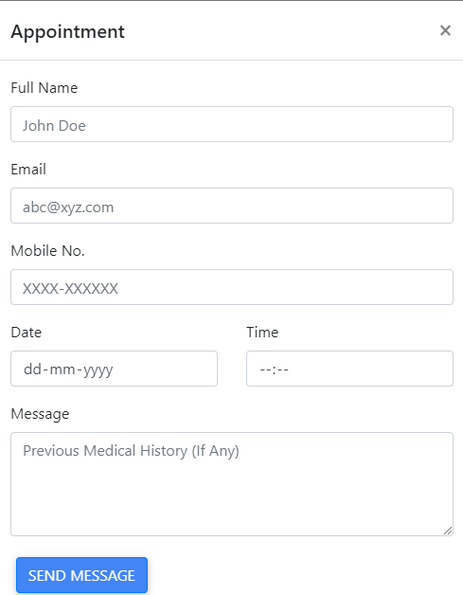

Appointment Form will be filled by the user so that, Doctor will get the information of the patient and time and date of the appointment.

**3 Testimonials**

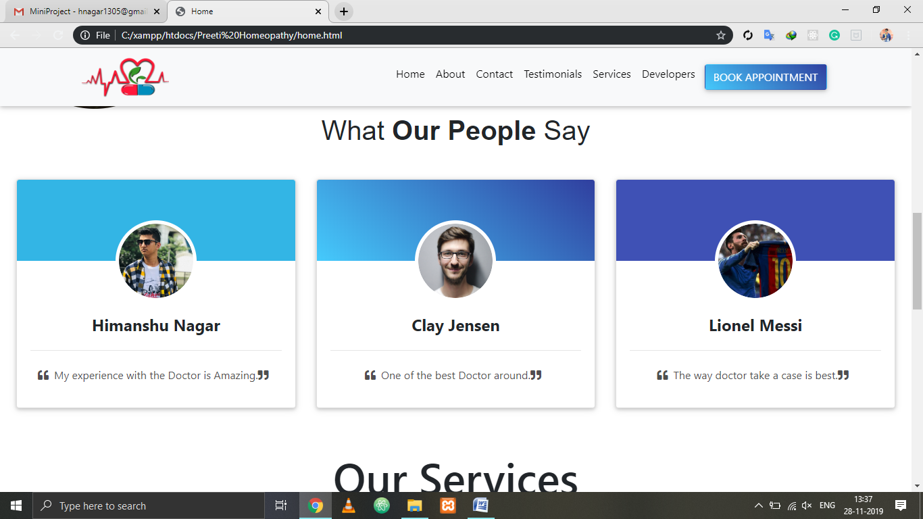

Testimonials are used for the doctor so that other people can see the reviews and find it suitable for them. Better the reviews, more the patients will come. Doctor will put the photo, name and reviews of the patient.

**4 Services**

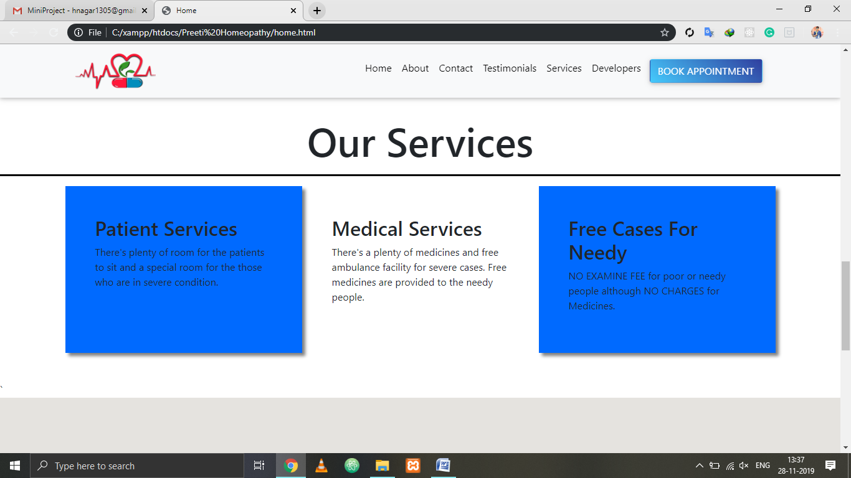

Services section is for patient to see what kind of services provided by the doctor.

**5 Map**

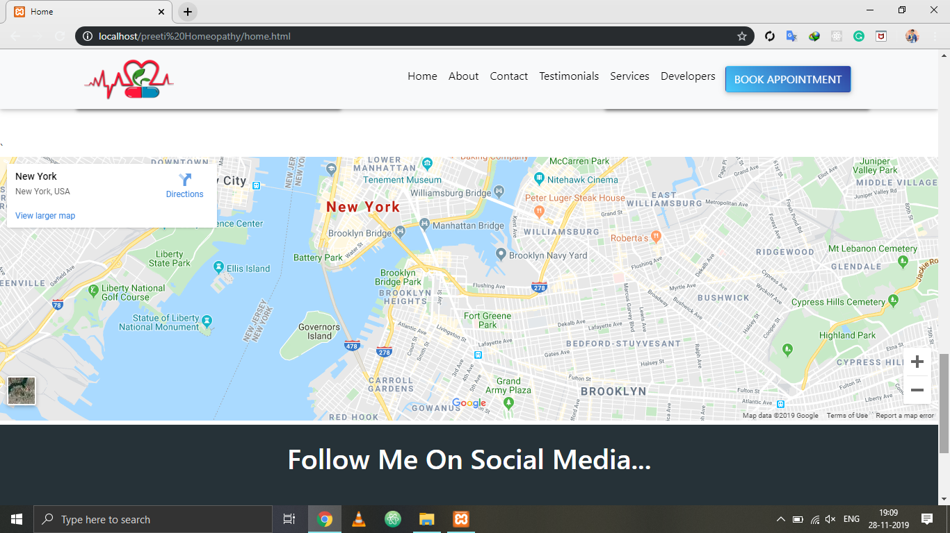

The Map is given for the user. When the user click on the map, the map will navigate user to the Doctor.

**TESTING**

* **Filled Form**

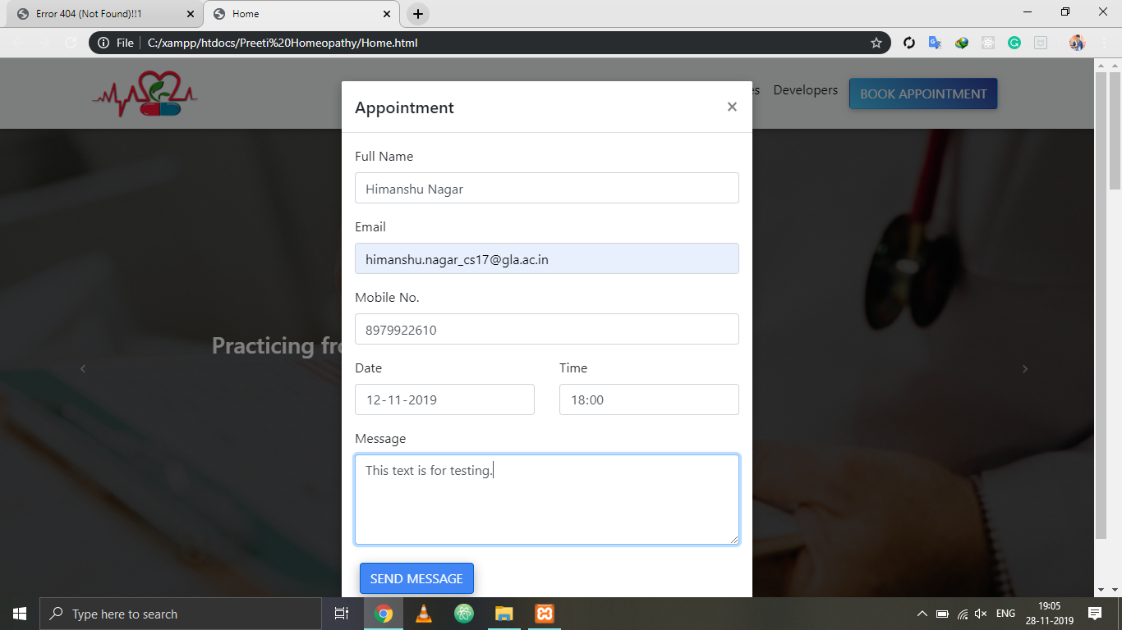

* **Email to User**

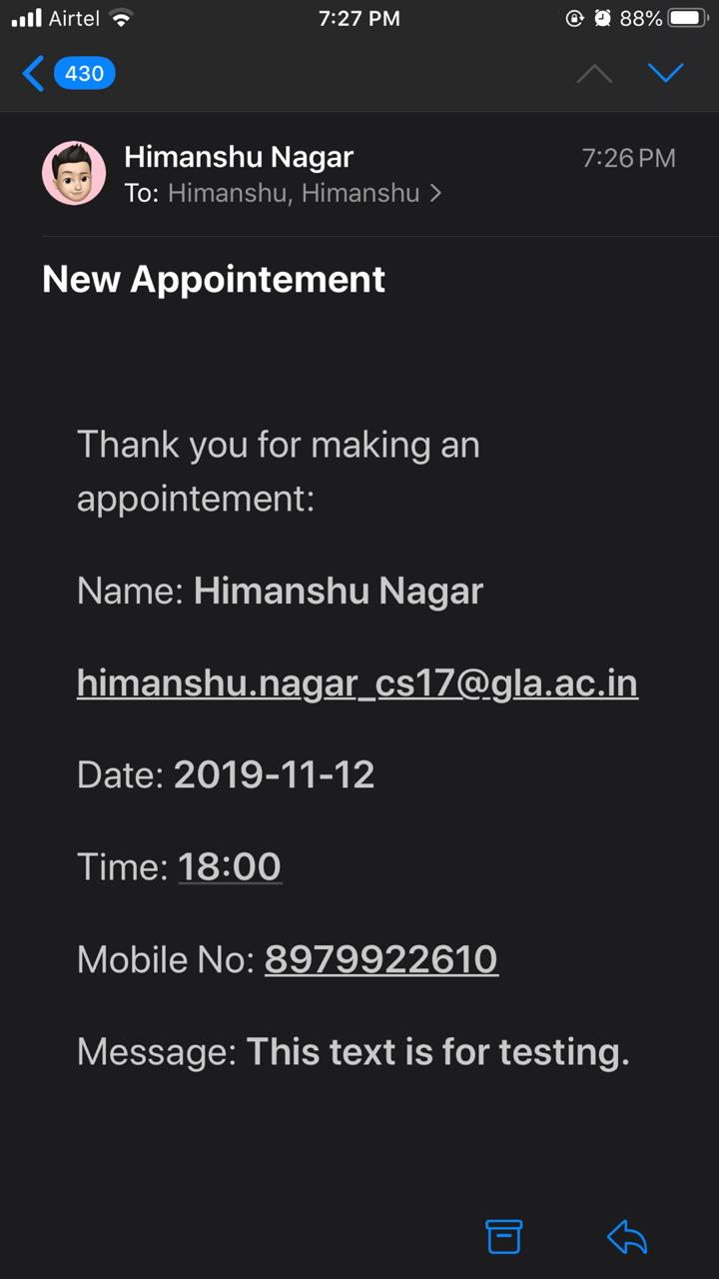

* **Email to Doctor**

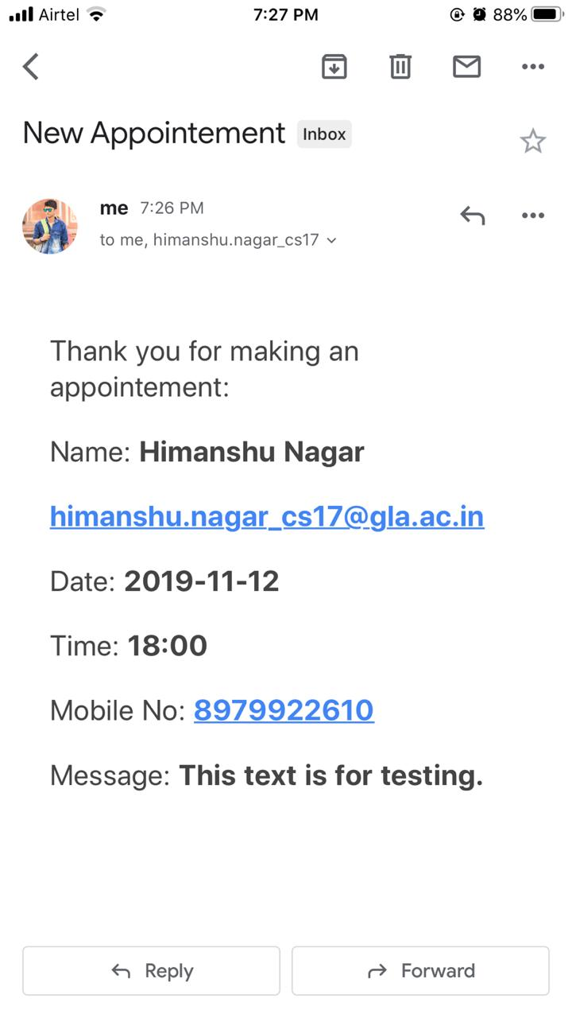

**Software Tecnologies Used:**

**2.1 Bootstrap**

Bootstrap is a free and open source front end development framework for the creation of websites and web apps. The Bootstrap framework is built on HTML, CSS, and JavaScript (JS) to facilitate the development of responsive, mobile-first sites and apps.

Responsive design makes it possible for a web page or app to detect the visitor’s screen size and orientation and automatically adapt the display accordingly; the mobile first approach assumes that smartphones, tablets and task-specific mobile apps are employees’ primary tools for getting work done and addresses the requirements of those technologies in design.

Bootstrap includes user interface components, layouts and JS tools along with the framework for implementation. The software is available precompiled or as source code.

**2.2 PHP**

PHP can be used on all major operating systems, including Linux, many Unix variants (including HP-UX, Solaris and OpenBSD), Microsoft Windows, macOS, RISC OS, and probably others. PHP also has support for most of the web servers today. This includes Apache, IIS, and many others. And this includes any web server that can utilize the FastCGI PHP binary, like lighttpd and nginx. PHP works as either a module, or as a CGI processor.

So with PHP, you have the freedom of choosing an operating system and a web server. Furthermore, you also have the choice of using procedural programming or object oriented programming (OOP), or a mixture of them both.

**2.3 Web Browser**

A web browser, or simply “browser,” is an application used to access and view websites. Common web browsers include Microsoft Internet Explorer, Google Chrome, Mozilla Firefox, and Apple Safari.

The primary function of a web browser is to render HTML, the code used to design or “mark up” web pages. Each time a browser loads a web page, it processes the HTML, which may include text, links, and references to images and other items, such as cascading style sheets and JavaScript functions. The browser processes these items, then, renders them in the browser window.

**2.4 Visual Studio Code**

Visual Studio Code is a lightweight but powerful source code editor which runs on your desktop and is available for Windows, macOS and Linux. It comes with built-in support for JavaScript, TypeScript and Node.js and has a rich ecosystem of extensions for other languages (such as C++, C#, Java, Python, PHP, Go) and runtimes (such as .NET and Unity).

Visual Studio Code is an editor first and foremost, and includes the features you need for highly productive source code editing. This topic takes you through the basics of the editor and helps you get moving with your code.

**Hardware Required**

* **CPU Speed -** 2.2 Ghz
* **Processor -** intel Pentium or Above
* **Display -**  Monitor
* **Memory -**  1GB or Above
* **Hard Drive -** 256GB or Above

**CHAPTER 3**

**IMPLEMENTATION & USER INTERFACE**

**3.1 User Interface**

**1 Nav-Bar and Hero Carousel**



**1.1 Nav-Bar –** Nav bar is the top of every page and it contains :

1. Logo at the left side
2. Menus at the middle
3. Appointment Button at right side

The NavBar is stick to the page so it will stays at the top always.

**1.2 Carousel –** Carousel contains 3 images and animated text.

**2 Rounded Image with Text**

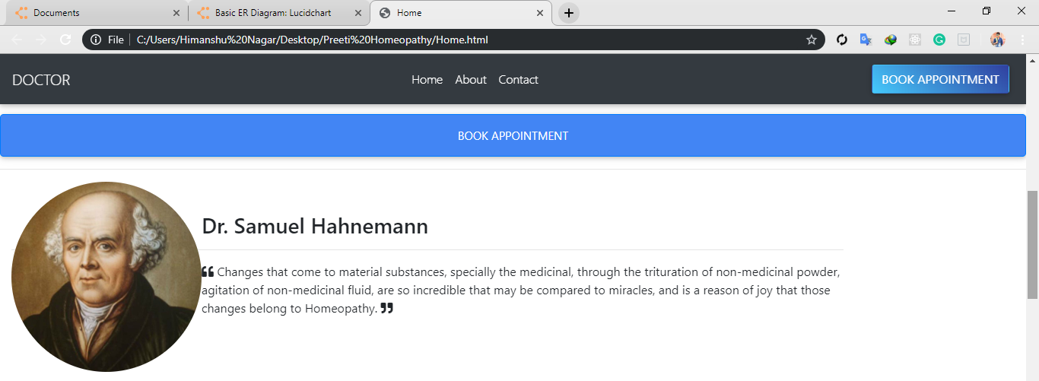

This image is of Dr. Samuel Hahnemann. He was the founder of Homeopathy.

**3 Testimonials**

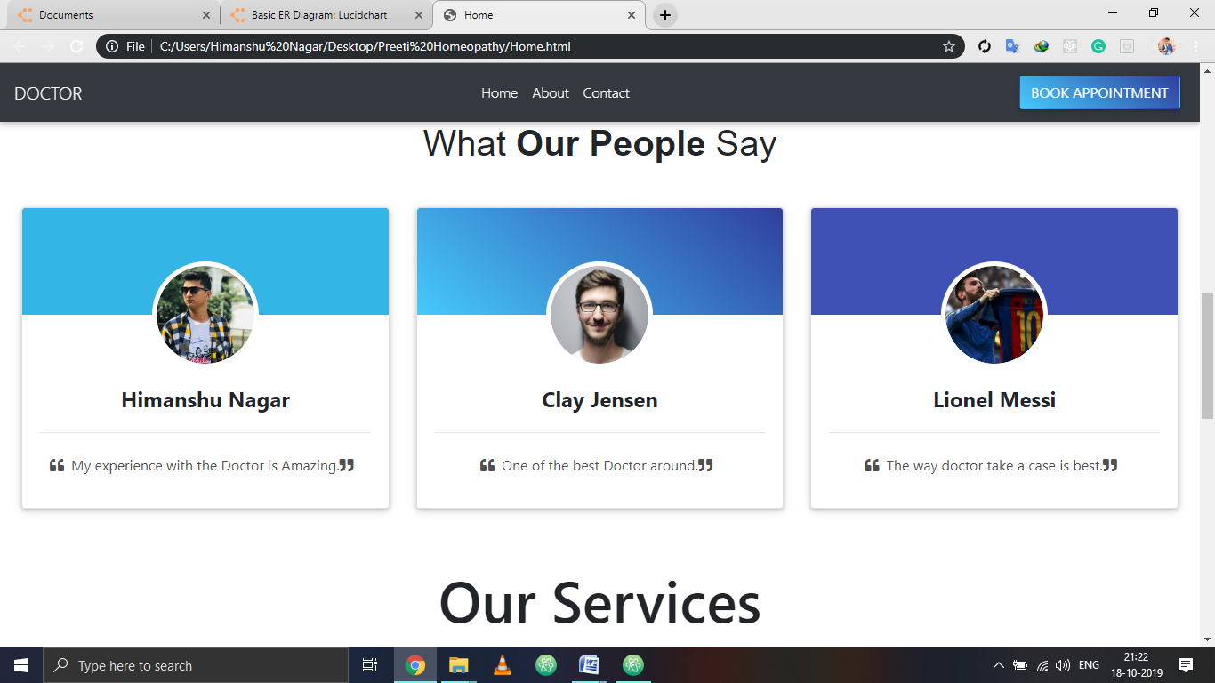

Testimonials are the feedbacks given by customers/patients etc.

**4 Map**

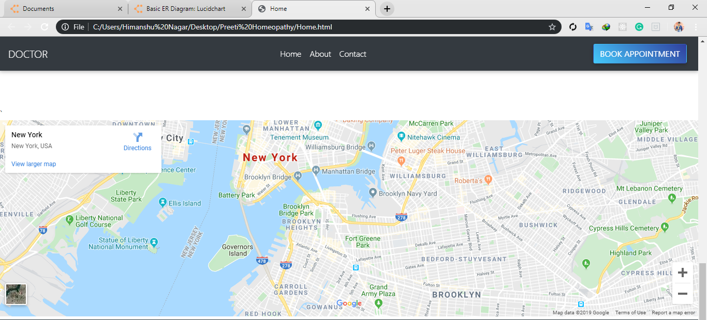

This map can give direction to a certain clinic/hospital.

**5 Footer**

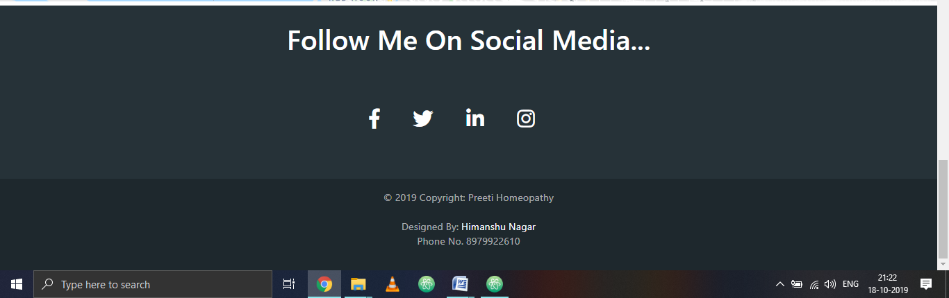

Footer contains Social Media Icons and Copyright statement with some developer details.

**6 Contact Form**

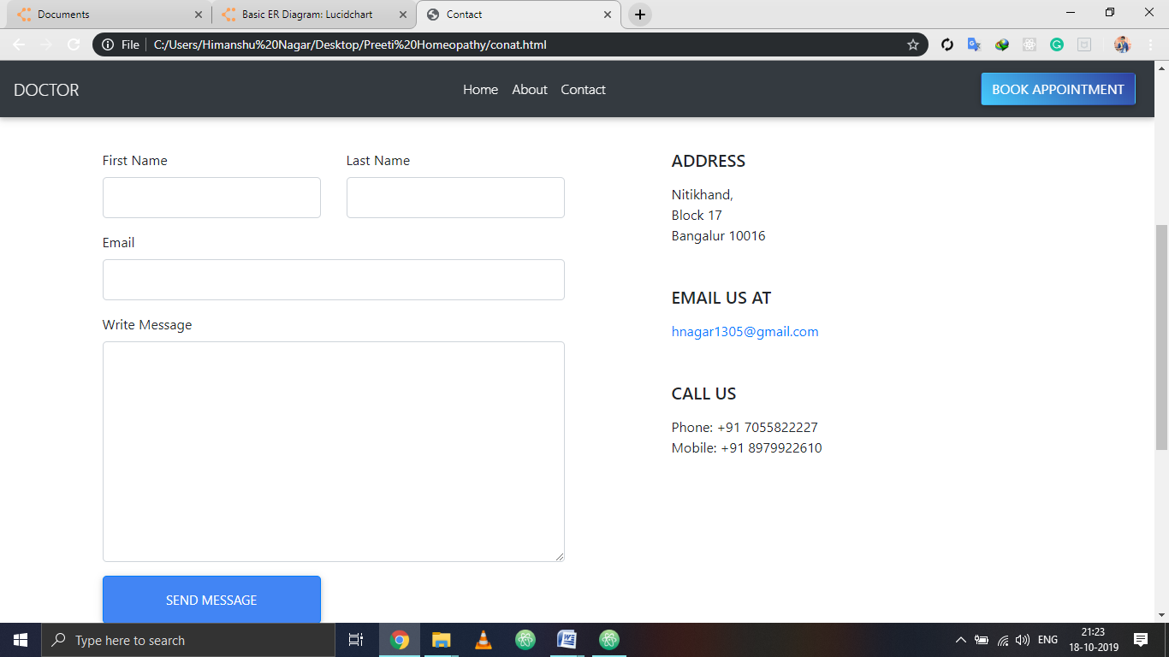

This is a contact form. With this form a user can send a message he/she wants to ask.

**7 Appointment Form**

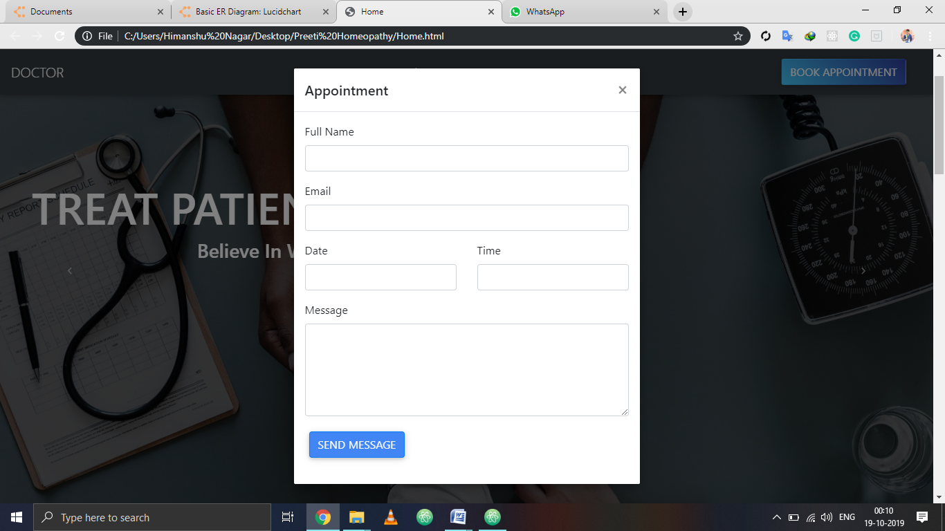

This is the form of appointment which is need to fill up for a appointment.

**3.2 Code Implementation**

**1 NAV-BAR**

<nav class="navbar fixed-top navbar-expand-md navbar-dark bg-dark">

<a class="navbar-brand" href="#">DOCTOR</a>

<button

class="navbar-toggler"

type="button"

data-toggle="collapse"

data-target=".navbar-collapse"

aria-expanded="true"

>

<span class="navbar-toggler-icon">

<span class="icon-bar"></span>

<span class="icon-bar"></span>

<span class="icon-bar"></span>

</span>

</button>

<div class="collapse navbar-collapse" id="navbarSupportedContent">

<ul class="navbar-nav mx-auto">

<li class="nav-item">

<a class="nav-link active" href="Home.php">Home</a>

</li>

<li class="nav-item">

<a class="nav-link active" href="educenter-premium/about.php">About</a>

</li>

<li class="nav-item">

<a class="nav-link active" href="file:///C:/Users/Himanshu%20Nagar/Desktop/Preeti%20Homeopathy/conat.php">Contact</a>

</li>

</ul>

<div class="btn-outer">

<a href="#" class="btn blue-gradient btn btn-rounded" data-toggle="modal" data-target="#modalAppointment">Book Appointment</a></button>

</div>

</div>

</nav>

**2 CAROUSEL**

<div id="carouselExampleIndicators" class="carousel slide" data-ride="carousel">

<ol class="carousel-indicators">

<li data-target="#carouselExampleIndicators" data-slide-to="0" class="active"></li>

<li data-target="#carouselExampleIndicators" data-slide-to="1"></li>

<li data-target="#carouselExampleIndicators" data-slide-to="2"></li>

</ol>

<div class="carousel-inner">

<div class="carousel-item active">

<img src="img/image (6).jpg" class="d-block w-100" style="height: auto;" alt="MESSI" >

<div class="carousel-caption" style="top:30%; left:-20%;">

<h1 class="animated fadeInDown delay-1s" position="absolute" top="40px" style="font-size:4em;">HOMEOPATHY EXPERT</h1>

<h3>Practicing from past 4 years!</h3>

</div>

</div>

<div class="carousel-item">

<img src="img/image (7).jpg" class="d-block w-100" style="height: auto;" alt="MESSI">

<div class="carousel-caption" style="top:30%; left:-20%;">

<h1 class="animated fadeInLeft delay-1s" position="absolute" top="40px" style="font-size:4em;">CARE FOR LIFE</h1>

<h3>Leading The Way In Medical Excellence!</h3>

</div>

</div>

<div class="carousel-item">

<img src="img/image (8).jpg" class="d-block w-100" style="height: auto;" alt="MESSI">

<div class="carousel-caption" style="top:30%; left:-15%;">

<h1 class="animated fadeInUp delay-1s" position="absolute" top="40px" style="font-size:4em;">TREAT PATIENT NOT DISEASE</h1>

<h3>Believe In What's Best For Us!</h3>

</div>

</div>

</div>

<a class="carousel-control-prev" href="#carouselExampleIndicators" role="button" data-slide="prev">

<span class="carousel-control-prev-icon" aria-hidden="true"></span>

<span class="sr-only">Previous</span>

</a>

<a class="carousel-control-next" href="#carouselExampleIndicators" role="button" data-slide="next">

<span class="carousel-control-next-icon" aria-hidden="true"></span>

<span class="sr-only">Next</span>

</a>

</div>

**3 FOOTER**

<footer class="page-footer font-small special-color-dark pt-4">

<div class="container">

<h1 style="text-align: center;">Follow Me On Social Media...</h1>

<!-- Grid row-->

<div class="row">

<div class="col-md-12 py-5">

<div class="mb-5 flex-center">

<!-- Facebook -->

<a class="fb-ic">

<i class="fab fa-facebook-f fa-lg white-text mr-md-5 mr-3 fa-2x" aria-hidden="true"></i>

</a>

<!-- Twitter -->

<a class="tw-ic">

<i class="fab fa-twitter fa-lg white-text mr-md-5 mr-3 fa-2x" aria-hidden="true"> </i>

</a>

<!--Linkedin -->

<a class="li-ic">

<i class="fab fa-linkedin-in fa-lg white-text mr-md-5 mr-3 fa-2x" aria-hidden="true"> </i>

</a>

<!--Instagram-->

<a class="ins-ic">

<i class="fab fa-instagram fa-lg white-text mr-md-5 mr-3 fa-2x" aria-hidden="true"> </i>

</a>

</div>

</div>

<!-- Grid column -->

</div>

<!-- Grid row-->

</div>

<div class="footer-copyright text-center py-3">© 2019 Copyright: Preeti Homeopathy<br><br>Designed By:<a href="https://www.facebook.com/himanshu.choco"> Himanshu Nagar </a><br><p>Phone No. 8979922610</p>

</div>

</footer>

**4 TESTIMONIALS**

<section class="text-center my-3 p-4">

<h2 class="h1-responsive" style="font-family: Helvetica;">What <b>Our People </b>Say</h2>

<p class="dark-grey-text w-responsive mx-auto mb-5">

</p>

<div class="row">

<div class="col-lg-4 col-md-12 mb-lg-0 mb-4">

<div class="card testimonial-card">

<div class="card-up info-color"></div>

<div class="avatar mx-auto white">

<img

src="img/IMG_5768.jpg"

class="rounded-circle img-fluid"

/>

</div>

<div class="card-body">

<h4 class="font-weight-bold mb-4">Himanshu Nagar</h4>

<hr />

<p class="dark-grey-text mt-4">

<i class="fas fa-quote-left pr-2"></i>My experience with the Doctor is Amazing.<i class="fas fa-quote-right pr-2"></i>

</p>

</div>

</div>

</div>

<div class="col-lg-4 col-md-6 mb-md-0 mb-4">

<div class="card testimonial-card">

<div class="card-up blue-gradient"></div>

<div class="avatar mx-auto white">

<img

src="img/ZACK.jpg"

class="rounded-circle img-fluid"

/>

</div>

<div class="card-body">

<h4 class="font-weight-bold mb-4">Clay Jensen</h4>

<hr />

<p class="dark-grey-text mt-4">

<i class="fas fa-quote-left pr-2"></i>One of the best Doctor around.<i class="fas fa-quote-right pr-2"></i>

</p>

</div>

</div>

</div>

<div class="col-lg-4 col-md-6">

<div class="card testimonial-card">

<div class="card-up indigo"></div>

<div class="avatar mx-auto white">

<img

src="img/MESSI.jpg"

class="rounded-circle img-fluid"

/>

</div>

<div class="card-body">

<h4 class="font-weight-bold mb-4">Lionel Messi</h4>

<hr />

<p class="dark-grey-text mt-4">

<i class="fas fa-quote-left pr-2"></i>The way doctor take a case is best.<i class="fas fa-quote-right pr-2"></i>

</p>

</div>

</div>

</div>

</div>

</section>

**5 CONTACT FORM**

<section class="section">

<div class="container">

<div class="row">

<div class="col-md-6 mb-5 element-animate fadeInUp element-animated">

<form action="#" method="post">

<div class="row">

<div class="col-md-6 form-group">

<label for="fname">First Name</label>

<input type="text" class="form-control form-control-lg" id="fname">

</div>

<div class="col-md-6 form-group">

<label for="lname">Last Name</label>

<input type="text" class="form-control form-control-lg" id="lname">

</div>

</div>

<div class="row">

<div class="col-md-12 form-group">

<label for="email">Email</label>

<input type="email" id="email" class="form-control form-control-lg">

</div>

</div>

<div class="row">

<div class="col-md-12 form-group">

<label for="message">Write Message</label>

<textarea name="message" id="message" class="form-control form-control-lg" cols="30" rows="8"></textarea>

</div>

</div>

<div class="row">

<div class="col-md-6 form-group">

<input type="submit" value="Send Message" class="btn btn-primary btn-lg btn-block">

</div>

</div>

</form>

</div>

<div class="col-md-1"></div>

<div class="col-md-5 element-animate fadeInUp element-animated">

<h5 class="text-uppercase mb-3">Address</h5>

<p class="mb-5">Nitikhand, <br> Block 17 <br> Bangalur 10016</p>

<h5 class="text-uppercase mb-3">Email Us At</h5>

<p class="mb-5"><a href="mailto:hnagar1305@gmail.com">hnagar1305@gmail.com</a>

<h5 class="text-uppercase mb-3">Call Us</h5>

<p class="mb-5">Phone: +91 7055822227 <br> Mobile: +91 8979922610</p>

</div>

</div>

</div>

</section>

**6 POPUP FORM**

<div class="modal fade" id="modalAppointment" tabindex="-1" role="dialog" aria-labelledby="modalAppointmentLabel" aria-hidden="true">

<div class="modal-dialog" role="document">

<div class="modal-content">

<div class="modal-header">

<h5 class="modal-title" id="modalAppointmentLabel">Appointment</h5>

<button type="button" class="close" data-dismiss="modal" aria-label="Close">

<span aria-hidden="true">&times;</span>

</button>

</div>

<div class="modal-body">

<form action="contact.php">

<div class="form-group">

<label for="appointment_name" class="text-black">Full Name</label>

<input type="text" class="form-control" name="name" id="appointment_name">

</div>

<div class="form-group">

<label for="appointment_email" class="text-black">Email</label>

<input type="text" class="form-control" name="email" id="appointment_email">

</div>

<div class="row">

<div class="col-md-6">

<div class="form-group">

<label for="appointment_date" class="text-black">Date</label>

<input type="text" class="form-control" name="date" id="appointment_date">

</div>

</div>

<div class="col-md-6">

<div class="form-group">

<label for="appointment_time" class="text-black">Time</label>

<input type="text" class="form-control" name="time" id="appointment_time">

</div>

</div>

</div>

<div class="form-group">

<label for="appointment_message" class="text-black">Message</label>

<textarea name="" id="appointment_message" name="message" class="form-control" cols="30" rows="5"></textarea>

</div>

<div class="form-group">

<input type="submit" name="submit" value="Send Message" class="btn btn-primary btn-rounded">

</div>

</form>

</div>

</div>

</div>

</div>

**7 BACKEND**

<?php

if (isset($_POST['submit'])){

$name = $_POST['name'];

$email = $_POST['email'];

$date = $_POST['date'];

$time = $_POST['time'];

$Message = $_POST['Message'];

header("location:home.html");

}?>

<?php

require_once './vendor/autoload.php';

// Create the Transport

$transport = (new Swift_SmtpTransport('smtp.gmail.com', 465, 'ssl'))

->setUsername('hnagar1305@gmail.com')

->setPassword('nagar@5605705');

// Create the Mailer using your created Transport

$mailer = new Swift_Mailer($transport);

global $mailer;

$body = '<!DOCTYPE html>

<html lang="en">

<head>

<meta charset="UTF-8">

<title>Test mail</title>

<style>

.wrapper {

padding: 20px;

color: #444;

font-size: 1.3em;}

</style>

</head>

<body>

<div class="wrapper">

<p>Thank you for making an appointement:</p>

<p>Name: <b>'.$name.'</b></p>

<p><b>'.$email.'</b></p>

<p>Date: <b>'.$date.'</b></p>

<p>Time: <b>'.$time.'</b></p>

<p>Message: <b>'.$Message.'</b></p>

</div>

</body>

</html>';

// Create a message

$k = (new Swift_Message('New Appointement'))

->setFrom('hnagar1305@gmail.com')

->setTo(['hnagar1305@gmail.com',$email])

->setBody($body, 'text/html');

// Send the message

$result = $mailer->send($k);

if ($result > 0) {

return true;

} else {

return false;

}

**CHAPTER 4**

**REFERENCES**

1. JavaScript Enlightenment, Cody Lindley-First Edition, based on JavaScript 1.5, ECMA- 262, Edition

2. Mc GrawHill’s , Java : The complete reference 7thEdition, Herbert Schildit

3. Complete CSS Guide ,Maxine Sherrin and John Allsopp-O'Reilly Media; September

2012

4. http://www.w3schools.com/html/defualt.asp,

5. McGraw, G. and Felton, E. (1996) Java Security: Hostile Applets, Holes, and Antidotes. John Wiley & Sons, New York. (The first edition of this book.)

6. McGraw, G. (1998) Testing for security during development: why we should scrap penetrate and patch. IEEE Aerospace and Electronic Systems, 13(4):13-15, April 1998.

7. Neumann, P. (1995) Computer Related Risks. Addison-Wesley, Reading, MA.

8. Oaks, S. (1998) Java Security. O'Reilly & Associates, Sebastopol, CA.

9. Rubin, A, Geer, D. and Ranum, M. (1997) The Web Security Sourcebook. John Wiley & Sons, New York

10. Schneier, B. (1995) Applied Cryptography: Protocols, Alogorithms, and Source Code in C. John Wiley & Sons, New York. Second edition.

11. Shimomura, T. and Markoff, J. (1996) Takedown: The Pursuit and Capture of Kevin Mitnick, America's Most Wanted Computer Outlaw-By the Man Who Did It. Hyperion, New York.

12. Spafford, E. (1989) The Internet worm program: An analysis. Computer Communications Review, 19(1):17-57.

**Future Prospects:**

In future, we are going to add login for both patient and doctors to provide authentication to the users and are also going to add a chat-bot to solve the queries of the patient. The facility for cancelling appointments is not available we are going to add that and a table view of appointment would be shown on the home page of the website from where the patient and doctor can see their appointment and can plan their day accordingly and also can cancel the appointment and book a new appointment as per their convenience. We will also create a database on the backend for maintaining the previous history and prescriptions given to the patient. We would also include a emergency appointment option for the patients for emergency conditions. We would make a patient portal on which patient can go through his previous medical history and also include a bill payment module through which the patient can go through his bill history and can pay the previous and the current bill. And will also work on securing the website. And also In this Digital Era everyone is connected through network so it is possible that the huge amount of data in the network channel can create the congestion in the network. So, it is important to analyze the network congestion factors that we can use to reduce the congestion in the network which will also include the security aspects of data packets loss problems.

**Conclusion:**

The project **doctor’s appointment website** is for booking appointment with a doctor online to save time and to make it convenient for the patient to book appointments. The software takes care of all the information required to fix a appointment and reduces the paper work.

It sends a confirmation mail to the patient that the appointment is booked with all his entered details to verify the details. And it also sends a mail to the Doctor with the information of patient and the appointment time.

The project also provides information to patient about the hospitals and the patients who had taken treatment from the hospital in previous past.

It also provides the hospital location to the patient on map to get the direction to the hospital on a single click.